Short term plan

Unit of a long term plan Living Things |  | School: “Suykbulak secondary school”
Date: |  | Teacher name: Saurykova Aigul  SSerikkazyevna
Grade: 5 |  | Number present: 15 | absent:0
Lesson title Living things 1
Learning objectives | 5.4.2.1 understand with little support specific information and detail in short, simple texts on a limited range of general and curricular topics;  5.3.7.1 use appropriate subject-specific vocabulary and syntax to talk about a limited range of general topics  5.6.9.1 use simple present to describe routines, habits and states on a limited range of familiar general and curricular topics;
Lesson objectives | - Recognise with some support specific information and detail in short, simple texts.  - Apply appropriate subject related vocabulary and syntax in a speech.  - Apply simple present to describe routines, habits, and states on a gamiliar general and curricular topics.
Assessment criteria | identify with little support specific information and detail in short, simple texts on a limited range of general and curricular topics;  apply appropriate subject-specific vocabulary and syntax to talk about a limited range of general topics  apply simple present to describe routines, habits and states on a limited range of familiar general and curricular topics;
Level of thinking  skills | Knowledge and Comprehension  Application

Stages / Time | Teachers actions | Students actions | Assessment | Resources
Org. moment  1 min  Lead in  2 min | Greeting  - Good morning children! How are you?  - Dividing into groups. “Find your puzzle”  Teacher’s instructions  - All of you have a piece of puzzles, and now you must find the another pieces of your puzzle to assembly and sit with them in one group.  T presents lesson objectives  - T uses `Taboo` game to indentify the theme.  Living things  Monkey  Bear  Snake  gazelle | Ss greet the teacher  Ss find the another pieces of their puzzle to assembly and take their seats  Ss are presented the lesson objective  Ss play “Taboo” game to identify the theme. | Encourage Ss who can name object that is connected with new lesson. | PPP slide 1  PPP Slide 2
Text-based approach  Pre-reading  2 min  While – reading/  Reading and understanding  8 min  Language analysis  14 min  Controlled practice  3 min  Freer practice  Speaking task  8-10 min | Teacher shows pictures of animals. And asks to name and describe the pictures. And asks to guess what the text will be about .  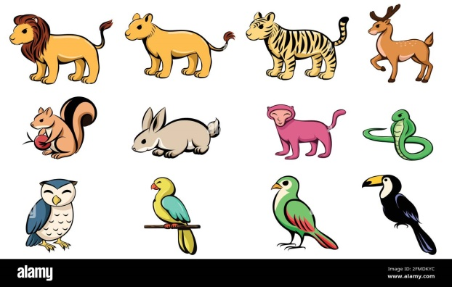  Read the text “At the zoo”. While reading the text ,write what happens at that time below:  - 6:00 _________________  - 7:30__________________  - 8:45__________________  - 9:30__________________  Target language discovery.  -T writes the sentence on the board, and asks Ss to find appropriate ones. They should find 6 sentences .  Anar works at Semei zoo.  -Teacher asks:  - How do you think what is the tense?  Grammar explanation  Present Simple tense  - We use the present simple tense when an action is happening right now, or when it happens regularly.  How to form the simple present  Positive  I work  You work  He\she\it works  Negative (do, does)  I don’t work.  You don’t work.  He\She\ it doesn’t work.  Question  Do I work?  Do you work?  Does he\she\it work?  Timeline  Past now future  She feeds her dog everyday.  T asks CCQs  - Is she feeding her dog now?  - Is she going to feed her dog?  - Will she feed her dog?  - Does she feed her dog everyday  T gives practice task to Ss. They should fill in the gaps with following verbs in Present simple tense:  Not hunt, eat, live, live, drink, eat, live, eat, eat, not eat  - It ______ grass.  - They _______ in a group.  - They ________ animals.  - It ________ in a tree.  - It ________ water.  - Monkey _____ banana.  - ____ They ____ in a forest?  - ____ lion _____ leaves?  - ____ lizard and snake ____ insects?  - Lion ______ banana.  T suggests Ss to talk about their pets in pairs using subject-specific vocabulary.  You should:  - Use subject-specific vocabulary;  - Use Present Simple tense  - Pronounce the words correctly  Differentiation:  Ss who has lack of vocabulary will be given key words and directed questions: favourite pet, feed, spend time, bushy, cute, for a walk etc.  Directed questions:  What is your favourite pet?  How many time do you feed it per day?  What is your pet` favourite food?  Scaffolding  “Give time to talk”  T gives 2 min to process new ideas and information. | Ss name and describe the pictures, guess what the text will be about .  Ss read the text and do the task  Ss find the sentences from the text.  Ss Answer CCQs  Ss fill in the gaps.  Ss talk about their pets in pairs using subject-specific vocabulary. | Verbal evaluation  Descriptors:  1. reads the text  2. Writes what happens at the given times  - She wakes up.  - She feeds the snakes.  - She visits the monkeys.  - She visits the beautiful gazelles.  Descriptor:  - finds 6 sentences in Simple Present from the text.  Descriptor:  CCQ  - No  - No  - No  - Yes  Descriptor:  Fills in the gaps:  - Eats grass  - Live  - Don’t hunt  - Lives  - Drinks  - Eats  - Do, live  - Does, eat  - Do, eat  - Doesn’t eat | PPP  Slide 3  Picture from Alamy.com  Handouts:  Text “At the zoo”  PPP  Slide 4  PPP slide 5, 6  PPP slide 7  PPP slide 8  PPP slide 9
End of the lesson.  Reflection  5 min | The Ladder method was used as a reflection. T asks SS to stick their stickers to the Success Ladder | Ss use their stickers to show their knowledge according to the lesson  Green- I understood  Yellow-I have some questions  Red-I need a help.  Aim: To know how many Ss got the theme.  Efficiency:  Ss can use colors to show how much do they remember.  Differentiation: «Conclusion» method is used to finish the lesson. | Ss evaluate each other and encourage classmate with phrases like:  Well done! Brilliant! Good job! I like it! | Whiteboard  Poster.

Resources

At the zoo

Anar works at Semei zoo. Every morning She wakes up at six o`clock. At six fifteen she eats breakfast and drives to the zoo. She starts work at seven o`clock. First she feeds the rabbits. Rabbits eat carrots. At half past seven she feeds the snakes. The snakes love to eat insects. At eight fifteen she goes to the lion`s cage. The lions eat meat. At quarter to nine she visits the monkeys. The monkeys love to eat bananas, and they eat right from Anar`s hand. At half past nine Anar visits the beautiful gazelles. The gazelles eat plants and leaves. Anar`s final stop is the sweet panda bears. She feeds them with bamboo. At eleven o`clock she meets her first group of students, and she gives them a tour aroun the zoo. Anar loves her job very much. At the end of the day she always happy to go home and dream about the beautiful animals.

PPP slide 1

PPP slide 2

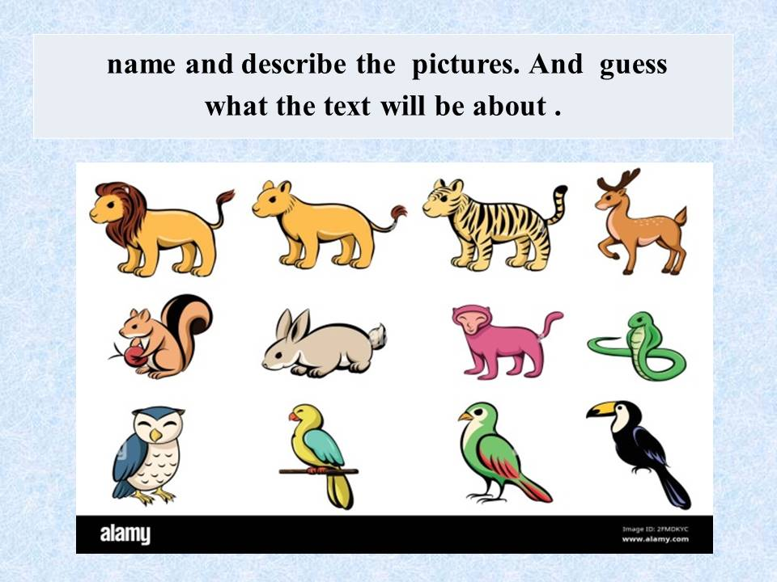

PPP slide 3

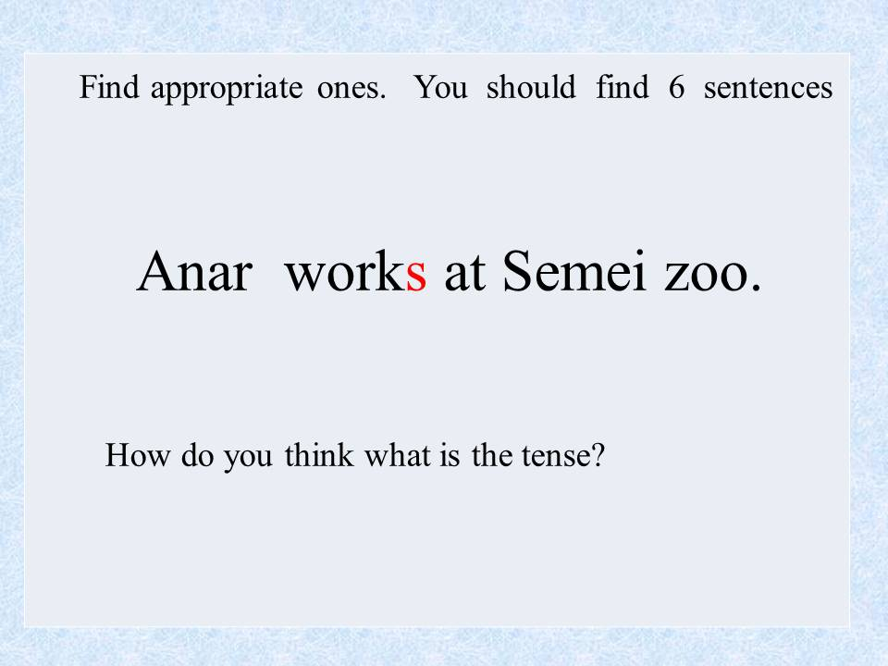

PPP slide 4

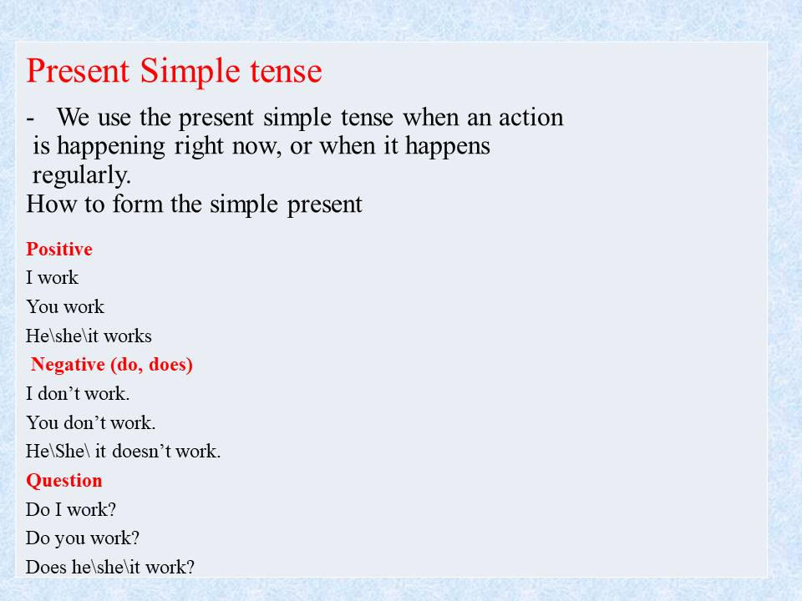

PPP slide 5

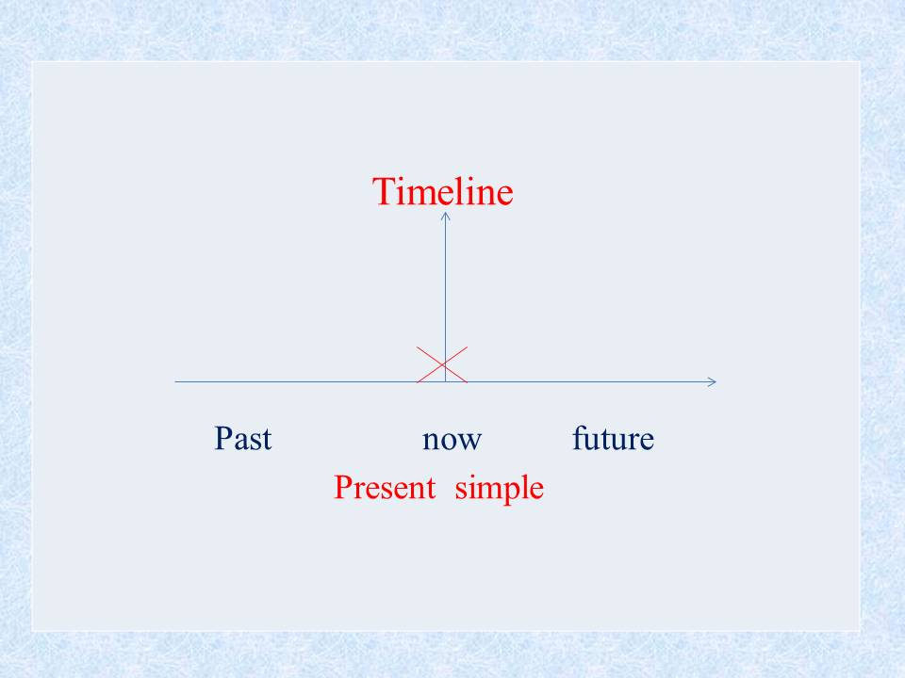

PPP slide 6

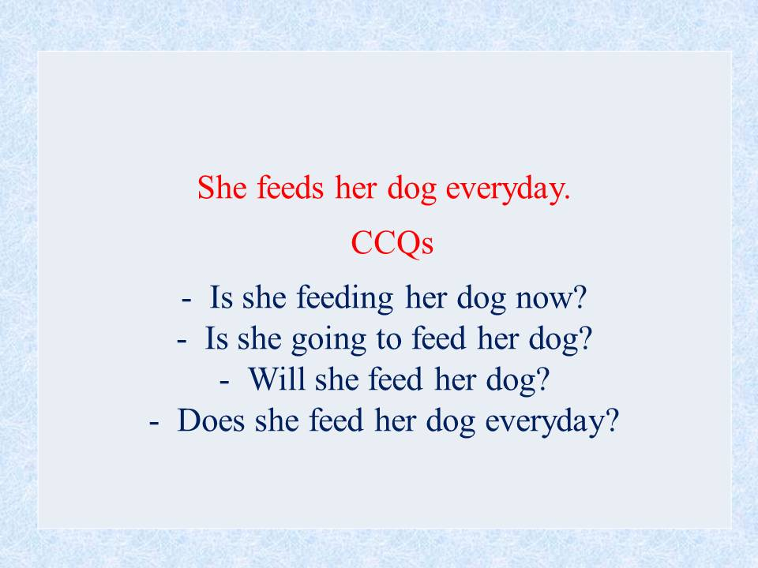

PPP slide 7

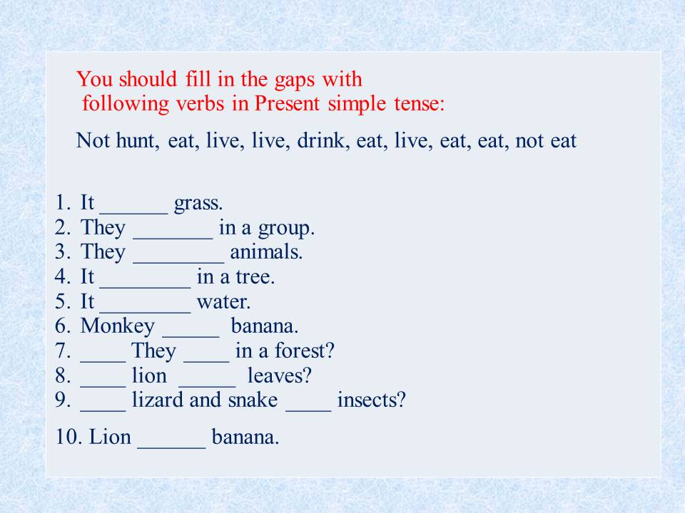

PPP slide 8

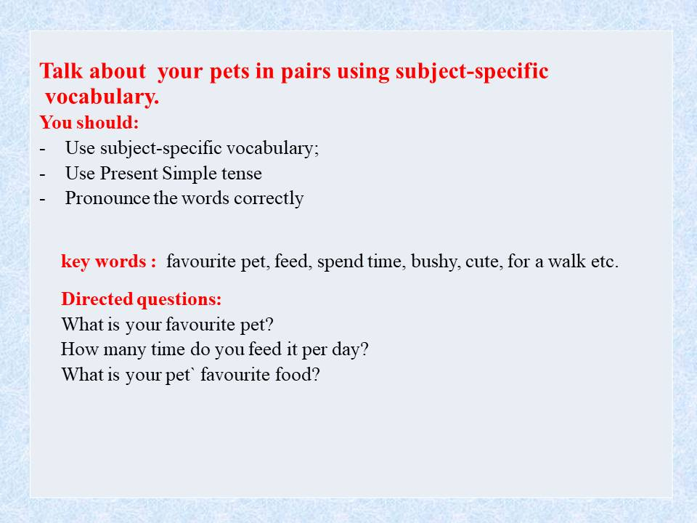

PPP slide 9

Unit of a long term plan Living Things
Lesson title Living things 1

Learning objectives
5.4.2.1 understand with little support specific information and detail in short, simple texts on a limited range of general and curricular topics;
5.3.7.1 use appropriate subject-specific vocabulary and syntax to talk about a limited range of general topics
5.6.9.1 use simple present to describe routines, habits and states on a limited range of familiar general and curricular topics;

Assessment criteria
identify with little support specific information and detail in short, simple texts on a limited range of general and curricular topics;
apply appropriate subject-specific vocabulary and syntax to talk about a limited range of general topics
apply simple present to describe routines, habits and states on a limited range of familiar general and curricular topics;

Level of thinking skills Knowledge and Comprehension
Application

Reading
Task 1
Read the text “At the zoo”. While reading the text ,write what happens at that time below:
- 6:00 _________________
- 7:30__________________
- 8:45__________________
- 9:30__________________

Assessment criteria  identify with little support specific information and detail in short, simple texts on a limited range of general and curricular topics; | Task  1 | Descriptor  A learner  Descriptors:  1. reads the text  2. Writes what happens at the given times  - She wakes up.  - She feeds the snakes.  - She visits the monkeys.  - She visits the beautiful gazelles. | Mark  1  1  1  1

Speaking
Task 2
T suggests Ss to talk about their pets in pairs using subject-specific vocabulary.
You should:
- Use subject-specific vocabulary;
- Use Present Simple tense
- Pronounce the words correctly
Directed questions:
What is your favourite pet?
How many time do you feed it per day?
What is your pet` favourite food?

Assessment criteria  apply appropriate subject-specific vocabulary and syntax to talk about a limited range of general topics | Task  2 | Descriptor  A learner  Asks 3 grammatically correct questions  Answers 3 questions properly  Uses topic related vocabulary accurately  Pronounces words and phrases clearly | Mark  1  1  0  0

Use of English
Task 3
T gives practice task to Ss. They should fill in the gaps with following verbs in Present simple tense:
Not hunt, eat, live, live, drink, eat, live, eat, eat, not eat

- It ______ grass.
- They _______ in a group.
- They ________ animals.
- It ________ in a tree.
- It ________ water.
- Monkey _____ banana.
- ____ They ____ in a forest?
- ____ lion _____ leaves?
- ____ lizard and snake ____ insects?
- Lion ______ banana.

Assessment criteria  apply simple present to describe routines, habits and states on a limited range of familiar general and curricular topics; | Task  3 | Descriptor  A learner  Fills in the gaps:  - Eats grass  - Live  - Don’t hunt  - Lives  - Drinks  - Eats  - Do, live  - Does, eat  - Do, eat  - Doesn’t eat | Mark  0,5  0,5  0,5  0,5  0,5  0,5  0,5  0,5  0,5  0,5  Total: 11

